My School in 100 Words

By Samuel Veloso

I’m new at school. My first day was not very fun. I was scared and nervous. During recess I played with no one. I just sat down and wrote. I didn’t even talk. I tried my best not to be noticed. The classes were very entertaining though, and I learned a lot.

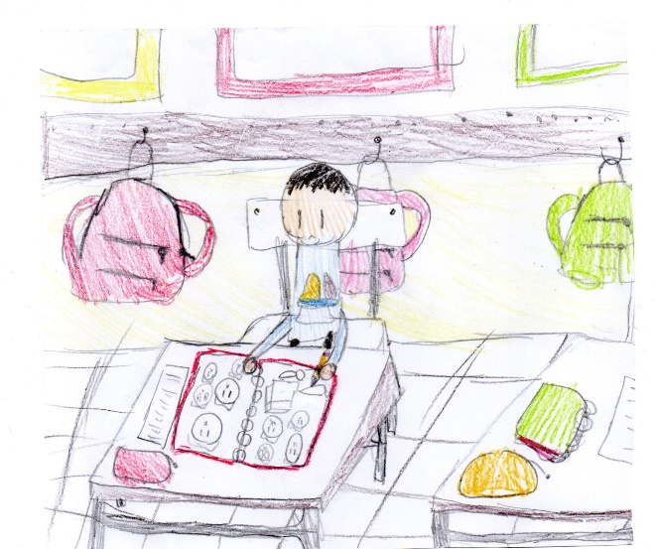 A month and two weeks later, guess what? I don’t feel scared anymore. I’ve made a bunch of new friends, and we laugh and play a lot. Now I think the school is a fun and happy place for me.

